# 

# 

# 

# 

# Prototype Password Manager Workflow

On installation of the extension, a new tab or window will open. In this window, the user will be prompted to set a master password to secure the password manager. The password will follow a minimum criteria intended to create a strong and easily remembered keyphrase.

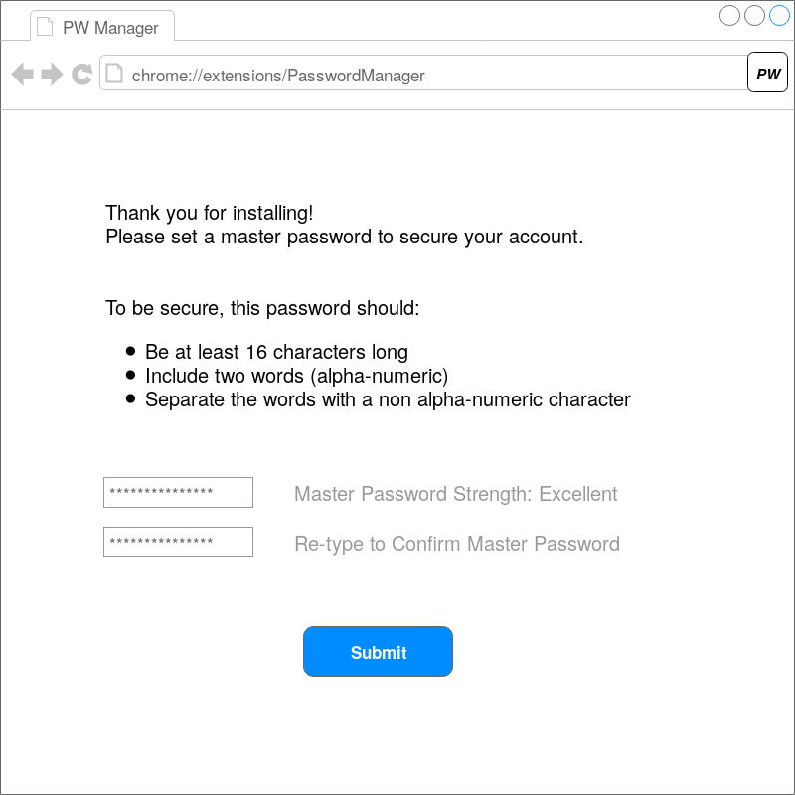

This password is also compared to common and easily cracked password sub-strings using a dictionary. If the master password is not of sufficient quality, it will be rejected.

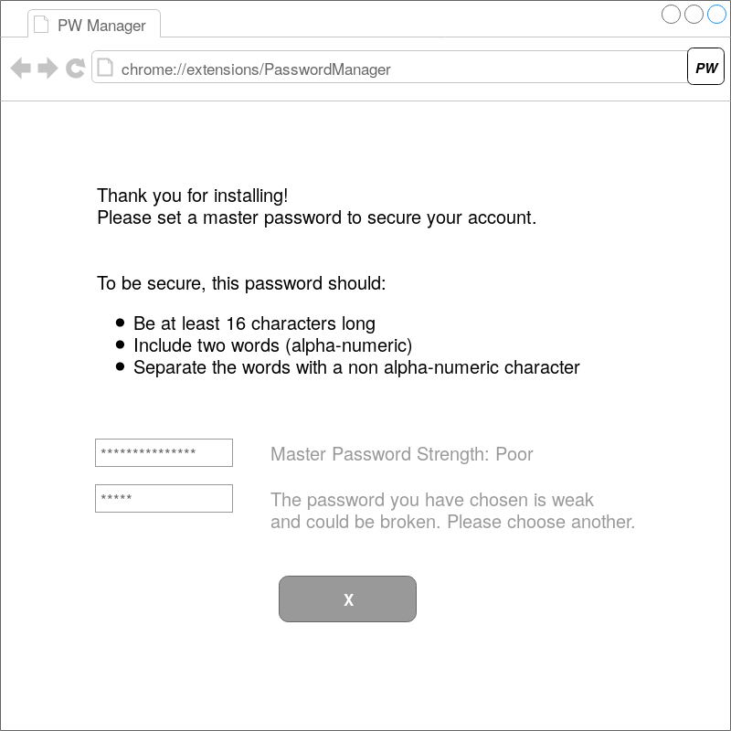

When visiting a new website and creating an account, the user is given the option of generating the password through the password manager. This takes the form of a pop-up that appears next to or on top of the password box. The default action is to generate a password for the website.

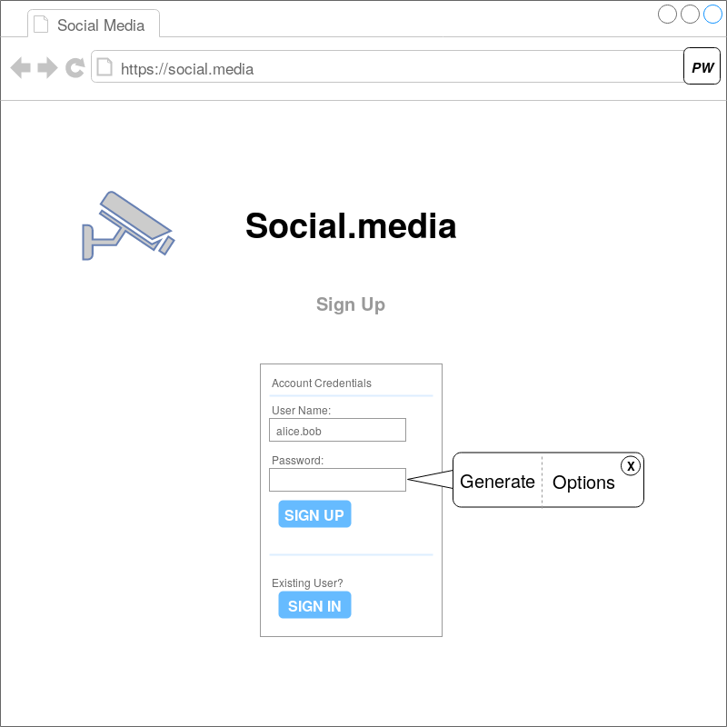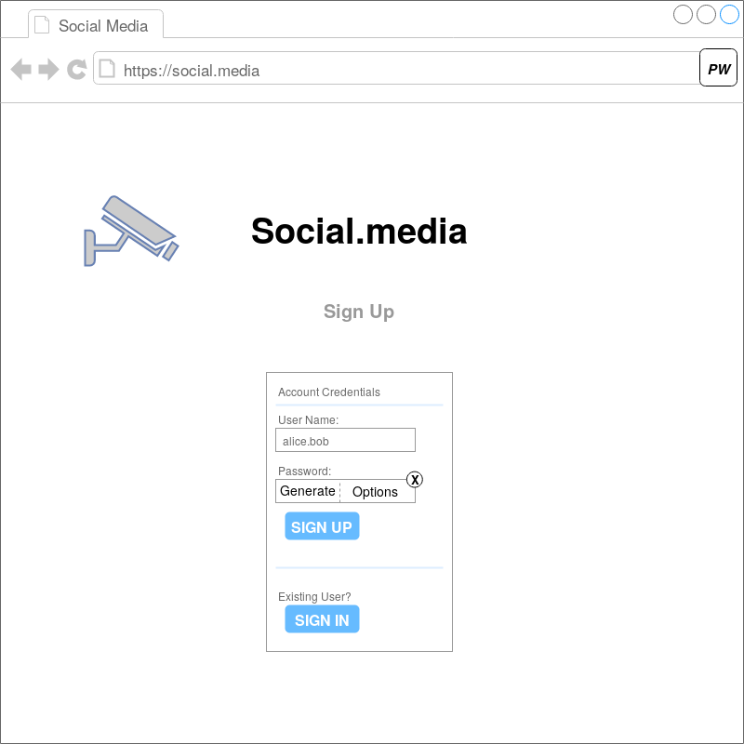

There is also an option of specifying generation settings to help make the password memorable and allow for flexibility if the website has specific criteria. The user can dismiss this dialog if necessary.

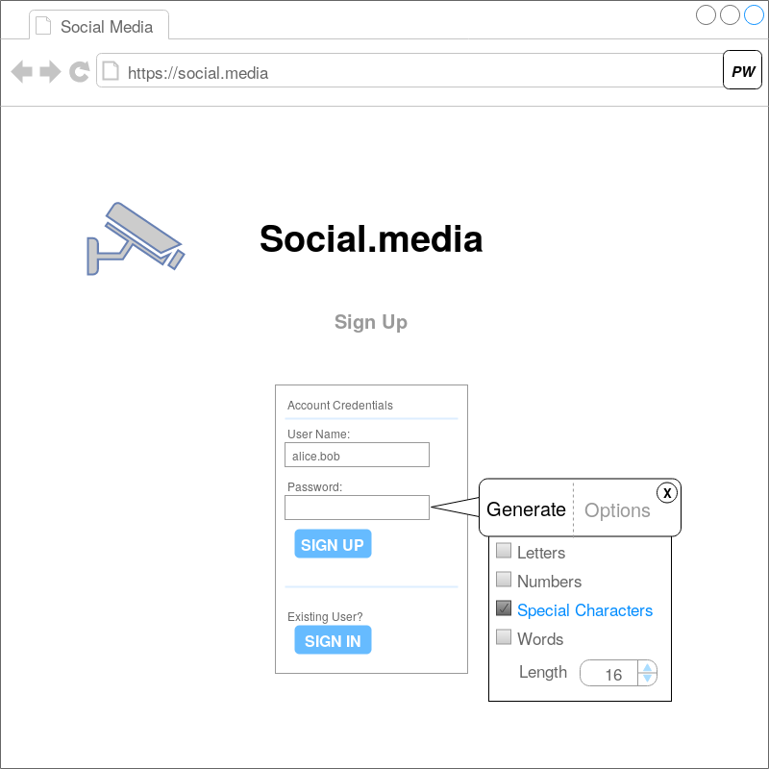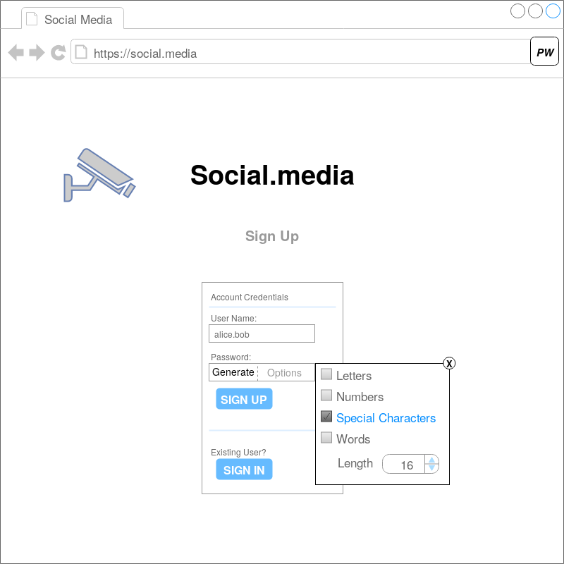

After creating the account, the user is prompted to save the password in the password manager.

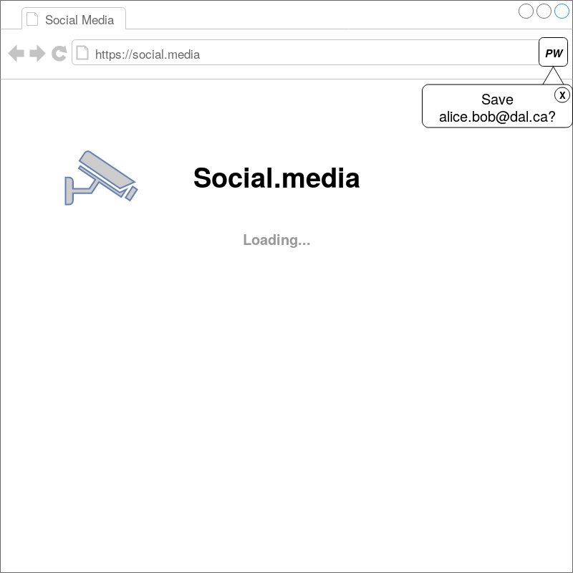

Upon subsequent visits to the login web page, the user is prompted to make use of the saved account associated with the website. This takes the form of a pop-up appearing next to the user text box on the page. The pop-up clearly identifies the user that will be used to automatically fill the credentials. If multiple accounts are associated with the website, a list of credentials to select from is provided instead with the same identifying information for each option. The user is able to dismiss the dialog if desired.

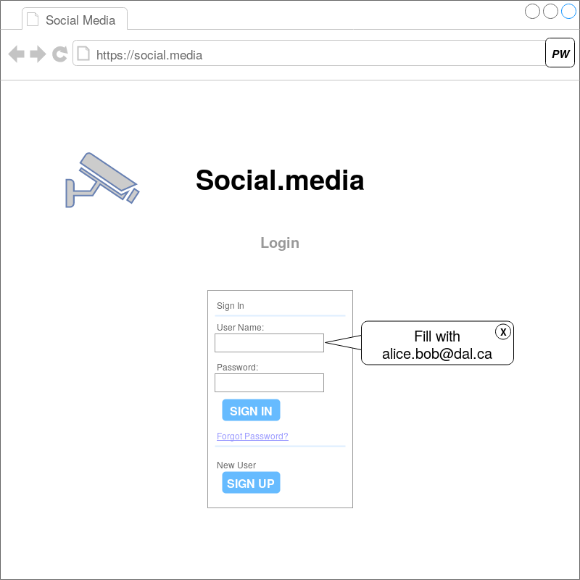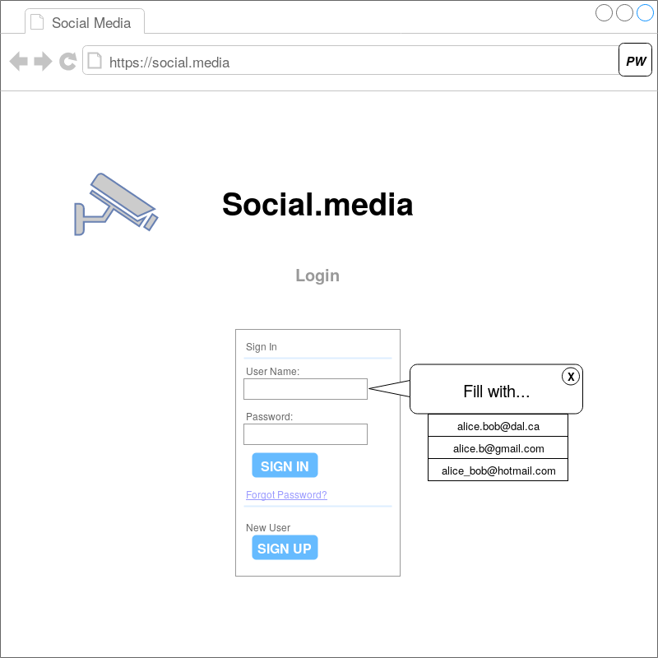

If the password for the account has changed, the user can update the password in the manager in one of three ways:

1. On a given website’s password update page, the user is prompted if they’d like to generate a password for their account, following the same pop-up options as new account creation. The user is then prompted if they’d like to store the new password for the account.
2. The user can open a drop-down menu from the icon on the browser bar when on a website with saved credentials. This provides an option to update the password, and also gives the option of generating a new password. Options for password specification are available to allow matching the website's password generation criteria.

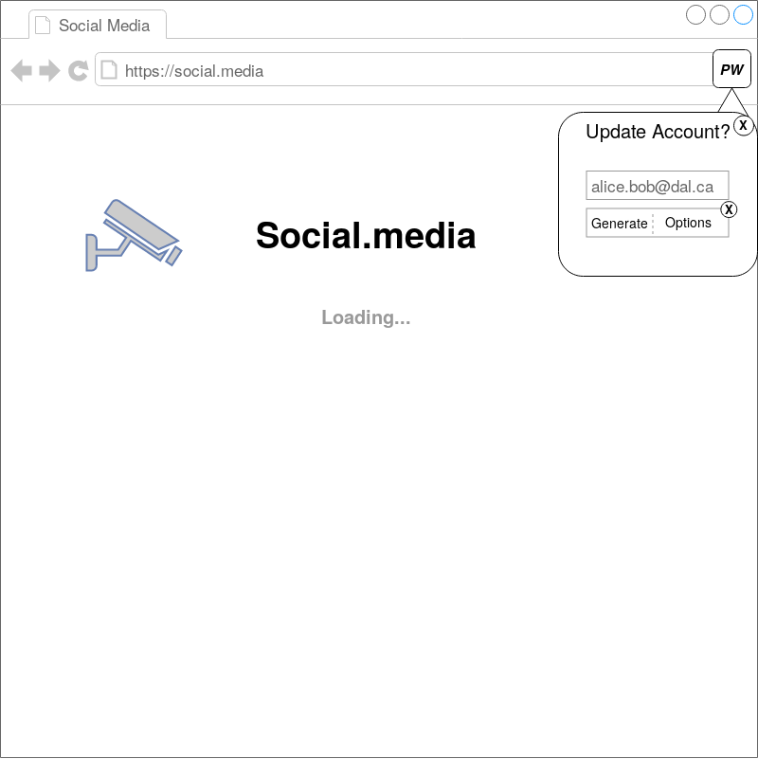

1. The user can open a new tab/window allowing for managing all password and accounts at any time. Each account is identified by the username used and the website associated. This allows for updating passwords using either a generated password similar to account creation or a user-defined password. This page also allows the user to delete accounts from the password manager through the options dialogue.

